UNDERGROUND SYSTEM - PROMO / BOOKING ASSETS

Tech Rider
Stage Plot & Input List
Press Photos
Into The Fire EP Social Media Assets
Logos
Live Band Videos
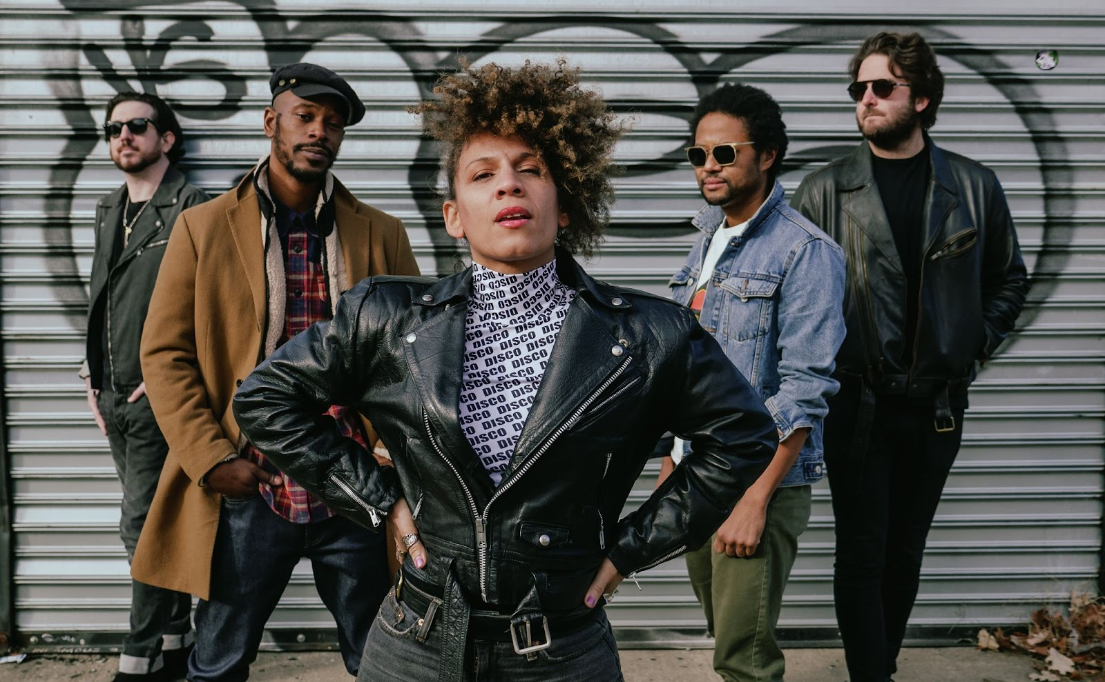
BIOGRAPHY
You don’t forget an Underground System show, as anyone who’s ever witnessed their larger-than-life live presence will attest.
One of New York City’s most dynamic recent acts, Underground System continues to reinvent their brand of global dance music. From an initial purist interpretive approach to Fela Kuti style afrobeat, to drawing on a legacy of NYC indie dance inspirations, the band has crafted a peerless and incendiary sound.
Springboarding off the production and release of their internationally acclaimed 2018 debut LP ‘What Are You’ (Soul Clap Records), the band brought their special brand of re-contextualized afrobeat, dance punk, disco and electronic music to audiences worldwide.
Attention from national outlets such as Billboard, NPR/PRI, KCRW’s most underrated album of the year, a US tour with labelmates Soul Clap and Midnight Magic, and the growing word of mouth enthusiasm within their local NYC community kickstarted the band's journey abroad.
In December 2018, Underground System’s featured performance at French tastemaking festival Transmusicales was so well received that it launched them into an 18-show European tour in 2019. Appearances included Eurockeennes de Belfort, Fusion Festival in Germany, and a headlining slot at Laurent Garnier’s Festival Yeah!. Heavy EU radio play, press, and remixes from dance music legends Gerd Janson and Greg Wilson continued to affirm this group’s idiosyncratic Brooklyn-bred sound was meant for the global stage.
Following a whirlwind year, the abrupt lockdown in 2020 was an opportunity to pause and return to home; encouraging co-leaders Domenica Fossati and Peter Matson to write and produce music that served as both a reflection and a pointed, high energy response to the times. This moment of amplified creative output was also a time of discovery and new relationships. Much in the way the band has been able to take a unique locally developed sound further abroad, a partnership between Underground System, Brooklyn based label Razor-N-Tape, and Heavenly Sweetness in the EU will lead the group into the next era.
A forthcoming EP, the first in a series of two, ‘Into the Fire’, will be released in Spring 2022. Featuring 3 originals and accompanying remixes from French maestro Yuksek, and Detroit legend Dez Andres, the EP is strong statement of where the band is at, and what’s to come.
Social Links: Spotify // Instagram // Facebook // Twitter

Promo & Social Media Assets // Desnuda - Video Assets & Digital Artwork + Single Artwork

Desnuda Photoshoot Selects

EPK 2020 (slightly outdated, but has a lot of info)

Into The Fire EP - Release Schedule

Promo & Social Media Assets // EP Audio (Please check with us before using)

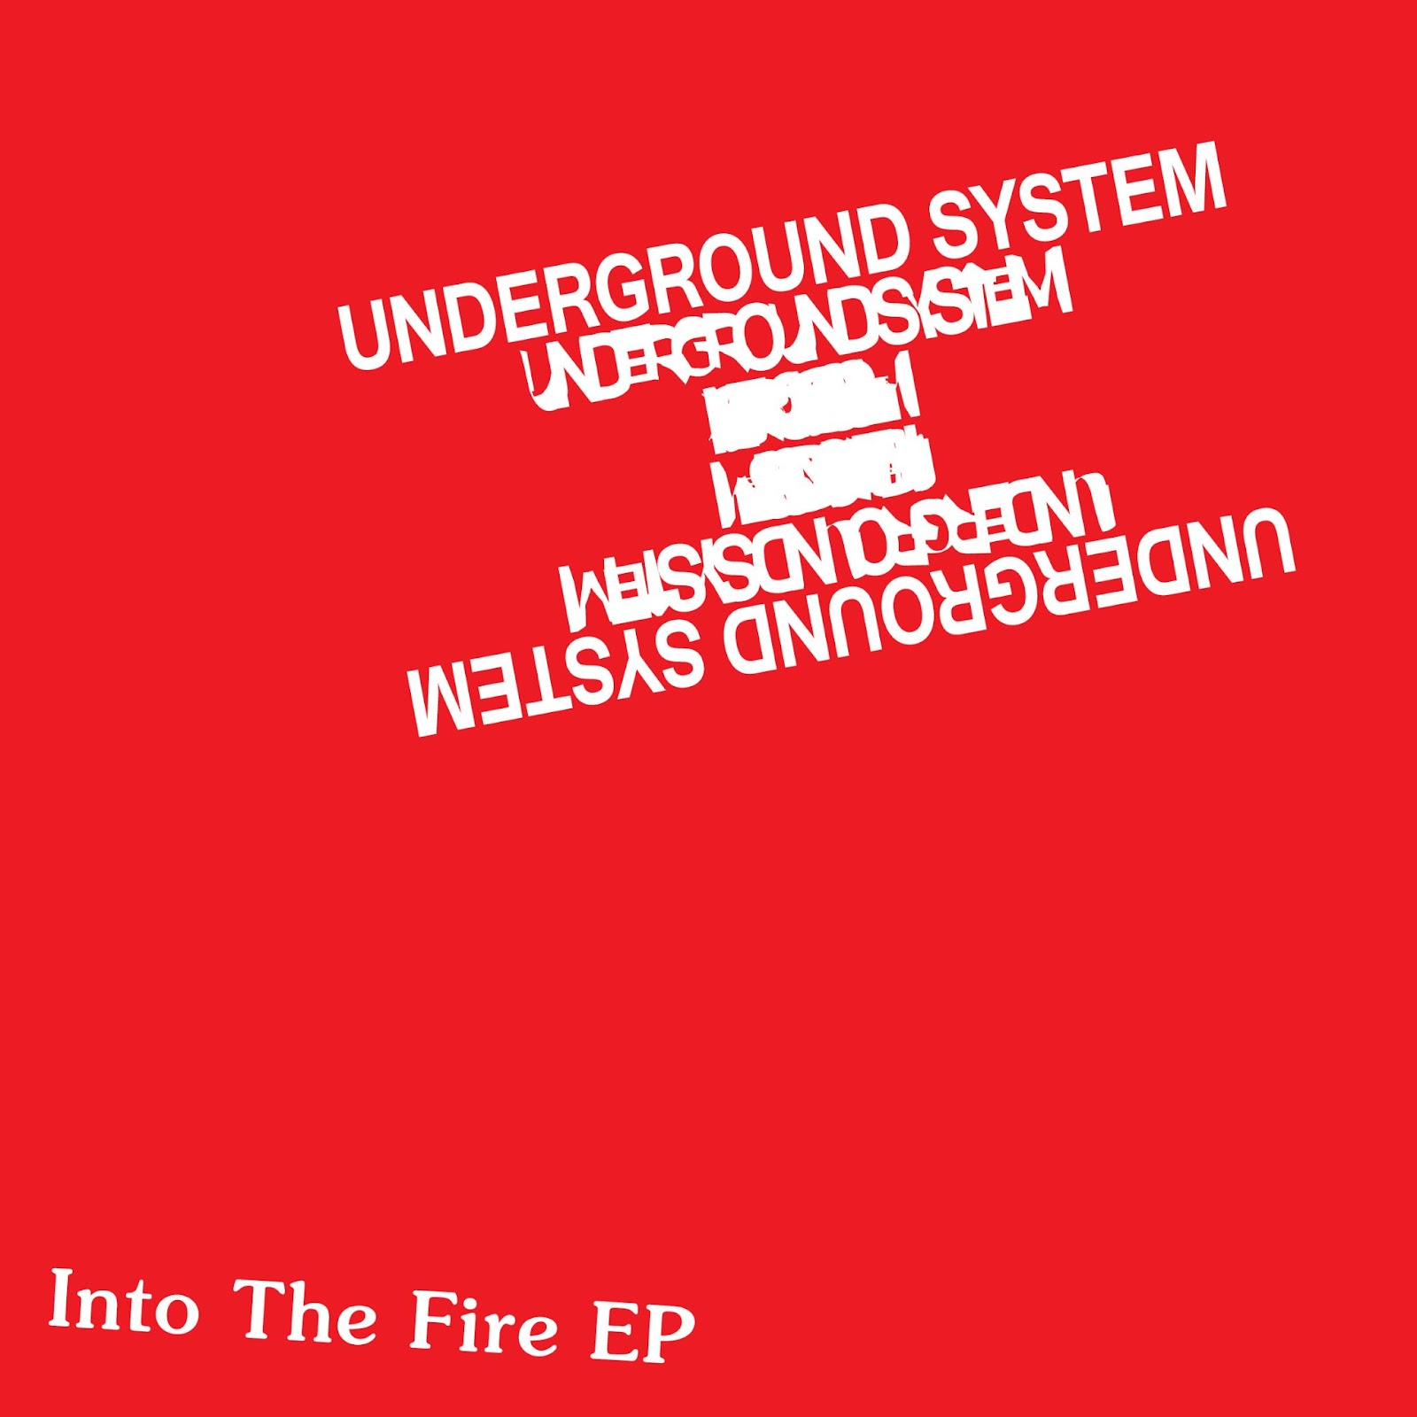
Feb 4th | Desnuda + Desnuda (Yuksek Remix) Streaming
April 22nd | He Said She Said, 2nd Single Streaming
April 29th | Into The Fire (Andres Remix) Streaming
May 6th | Full EP Streaming + Vinyl + Traxsource / Beatport Pre-Orders
May 20th | Full Digital Release (Bandcamp, Traxsource, Beatport, Juno DL)

