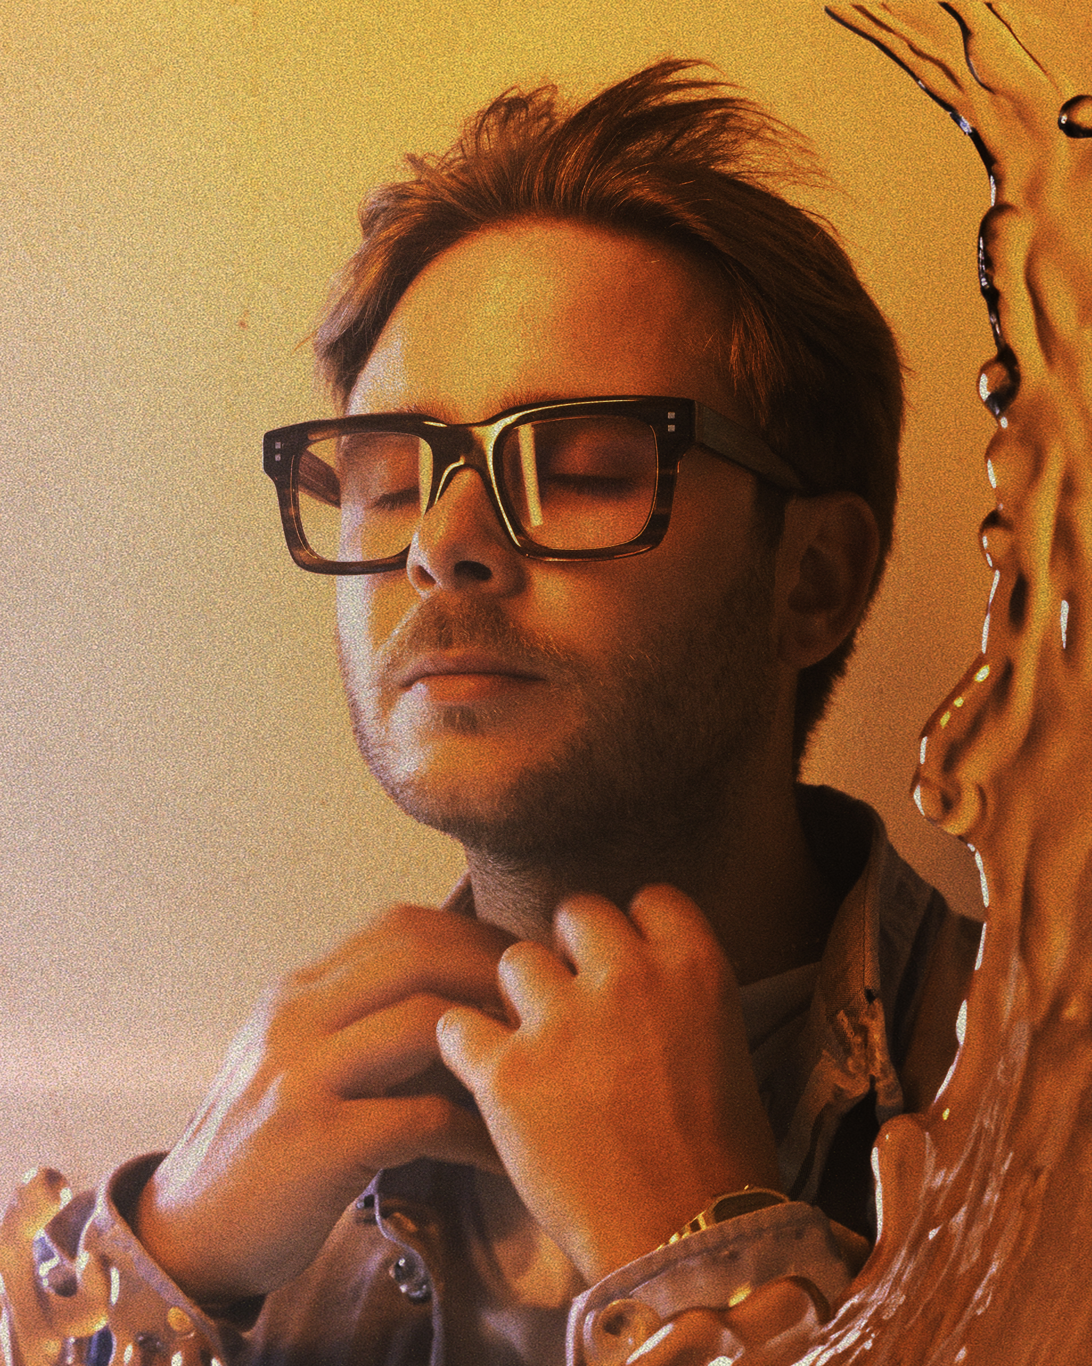

ROMAIN GARCIA

[LONG BIO]
Heir to pioneers like French 79, NTO, and Elderbrook, yet guided by sunnier, more pop-infused sounds, Romain Garcia embodies the new wave of melodic techno, somewhere between danceable Melodic House and radiant Deep House. Early on, his dreamy, exotic-tinged style caught the attention of a select few, including none other than Ben Böhmer. Their creative spark gave birth to the track “Cappadocia”, released on Cercle Records, now certified Gold as an export single (+40M streams).
After releasing White Flag on German label Ton Topferei in 2021, Romain joined NTO’s management team and unveiled his debut EP Syamo.
This was followed by his signing to the prestigious UK label Anjunadeep, where he released Before You Go, a 4-track project instantly praised by the French press (Tsugi, Libération) and heavily aired on US radio Sirius Chill.
With the foundations of an international career laid, Romain broadened his horizons through notable French collaborations, including a feature on DJ Pone and Disiz’s track, while amassing hundreds of thousands of monthly listeners across streaming platforms.
Romain is already performing on Europe’s most iconic stages (Printworks, Fuse, Phantom) and also across the US, South America, India, and Australia.
His swift rise caught the eye of French national TV, which followed him for a year to produce a 90-minute documentary aired on France 2: “Romain Garcia, Naissance d’un DJ”.
In 2024, Romain continues to shape his signature sound with Digital Diva, a nostalgic ode to last summer. A soundtrack for waiting for the next.
Because Romain wishes it would never end. Because he lives in the moment, with no thought for tomorrow. He gazes into the night and sees poetry in the void. He’s one of those who get lost to find themselves. One of those who still dream, eyes wide open.
From these imagined stories, a new chapter begins. Perhaps the most defining one of his career. With the release of his latest tracks Next To You, Alone, and Used To, Romain is sketching the outlines of something greater and more ambitious: his debut album, EURÊKA!’, out on October 17th, 2025.

[SHORT BIO]
Romain Garcia embodies the renewal of melodic techno, blending dreamy house with sun-soaked deep house. Spotted early by Ben Böhmer, their collaboration “Cappadocia” on Cercle Records is now certified Gold (+40M streams).
In 2021, he released his debut EP Syamo, then joined UK label Anjunadeep with Before You Go, praised by the French press and broadcast on Sirius Chill. His audience skyrocketed as he multiplied collaborations, notably with DJ Pone and Disiz.
Romain has already played on top-tier stages (Printworks, RedRocks, Madison Square Garden) and toured as far as Australia, India, and South America. France 2 dedicated a 90-minute documentary to his rise as a DJ-producer.
In 2024, he released Digital Diva, a nostalgic hymn to the summer that just passed. A soundtrack for waiting for the next. Because Romain doesn’t want it to end, he keeps dreaming. And with new tracks Next To You, Alone, and Used To, he opens a new chapter. One that marks the beginning of something larger: his debut album, EURÊKA!’, out on October 17th, 2025.
.

